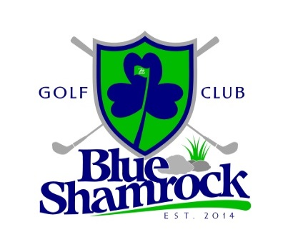
Blue Shamrock Golf Club
2015 Golf Outing Tournament Packages

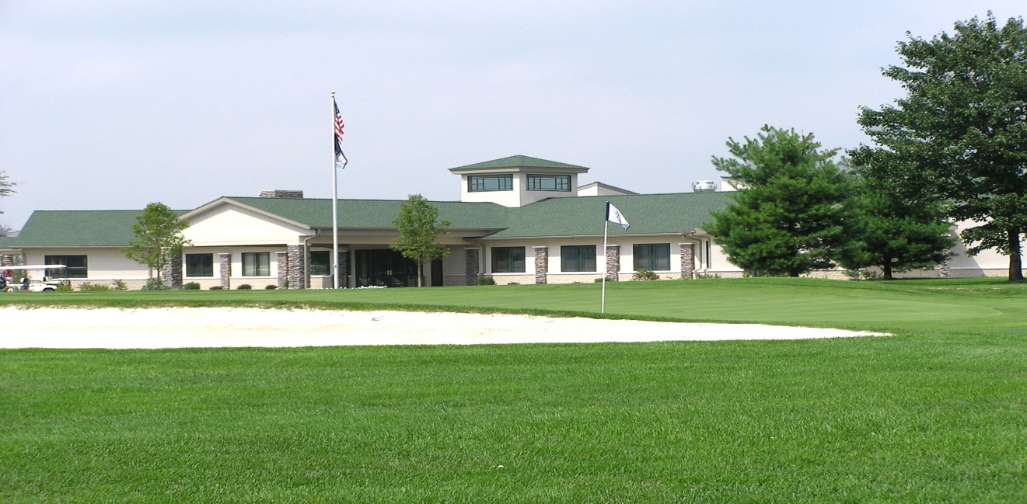

2230 Fireline Road
Palmerton, PA 18071
610-826-2504
www.golfblueshamrock.com
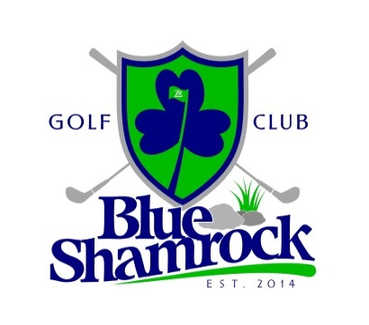
Welcome from the Management at Blue Shamrock Golf Club!
Thank you for considering Blue Shamrock Golf Club for your golf outing. Our knowledgeable and experienced management staff will help you in every way possible to make your event a success. We will ensure that your event runs smoothly while you entertain business associates, prospective clients or friends and family.
Planning and carrying out a golf tournament is sometimes a difficult task. Our goal is to make your pre-tournament preparations and day of the event go as smooth and enjoyable as possible. Our staff is always available to help you answer questions or assist you in any aspect of your event.
The golf course and clubhouse facilities are second to none at Blue Shamrock. The golf course is always in excellent shape and is challenging for the expert golfer as well as enjoyable for the novice golfer. The clubhouse facilities for events are beautifully designed and decorated for hosting your outing participants before or after your round. Of course, our number one goal for your event is customer service. We will tailor your event to meet your group’s needs with whatever is necessary to give your participants a day they will not soon forget.
As far as golf in concerned, our professional golf staff will ensure your golf tournament runs smoothly from start to finish. The following will be provided to you on the day of the event that is included in your package:
- Greens fee, cart fee and practice range availability
- Courteous golf bag check in and handling to the proper golf carts
- Placement of sponsor signs and banners prior to the event and removal immediately after
- Professionally printed scorecards, Hole assignment cards, and rule sheets for the event
- Use of sign holders and placement of Closest to Pin, Long Drive, etc. signs for contests
- Professional greeting and announcement of tournament scoring, on course contests, and local rules prior to the start of the event.
- Staff golf course monitoring to ensure comfortable pace of play for all participants
- Professional tournament scoring and tournament winners summary provided at the finish of the event.

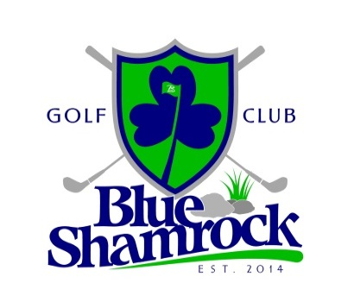
2015 Golf Outing Fees (Golf Only)
Monday-Thursday:
Group Size: Type of start: Golf Fees only:
49-71 players: partial shotgun start $39 per player
72-over players: full shotgun start $35 per player
Friday**, Saturday, Sunday:
Group Size: Type of start: Golf Fees only:
72 + players: Afternoon shotgun start $45 per player
**Contact Blue Shamrock if your group has less than 72 players on a Friday
Food/Beverage Regulations for Golf Outings:
Blue Shamrock Golf Club expects all events and organizations to attach Food and Beverage packages to their golf outing package. No outside food/beverage will be permitted to be brought in for your event. The following guidelines exist pertaining to food and beverage packages along with your golf tournament:
Monday-Thursday Events: If no food and beverage package is purchased for your event, you will be charged $5 per player for events under 72 players, and $4 per player for event with 72 or more players.
Friday-Sunday Events: Your organization is required to purchase at least a $20 food/beverage package to attach to your golf event.

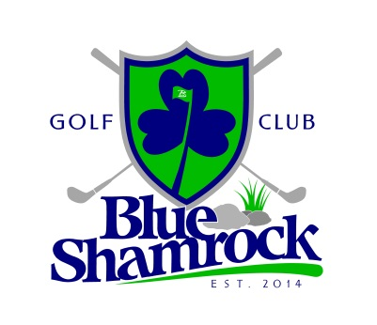
Golf Outing Menu Options
Blue Shamrock Golf Club is pleased to offer the following food and beverage options to organizations holding events at the club. In addition, we can customize a menu to meet your event’s needs if the following offers are not suitable. All food and beverage prices listed are inclusive of tax and gratuity.
Breakfast Menus:
Deluxe Continental Breakfast Buffet: $7.95/per person
Coffee, Assorted Juices
Bagels, Danish, and Muffins with accompaniments
Seasonal Fresh Fruit

Hot Breakfast Buffet: $10.95/per person
Scrambled Eggs
Pancakes or French Toast
Sausage or Bacon
Home Fries
Fresh Cut Fruit or Assorted Breakfast Pastries
Chilled Juices, Coffee & Tea
Lunch and Dinner Menus:
Boxed Lunch: $10.00/per person
Ham, Turkey, or Tuna Sandwich
Lettuce, Tomato, Cheese
Bag of Chips
Whole Fruit
Cookies
Soda or Bottled Water

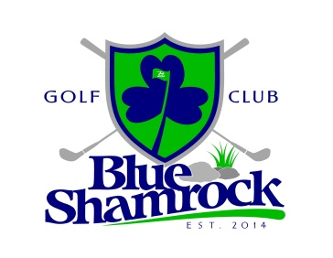
Customizable Shamrock Buffet:
Mixed Greens Salad, Rolls,
Chef’s choice of potato & seasonal vegetable, and assorted desserts.
Entrees
Honey Mustard Chicken
Bourbon BBQ Chicken
Chicken Marsala
Lemon Chicken
Herb-Crusted Pork Loin
Sausage & Peppers
Slow-Roast Beef au Jus
Tilapia Scampi
Baked Ziti
Tortellini Primavera
Homestyle Macaroni & Cheese
2 Entrée Selections: $24.95/per person
3 Entrée Selections: $28.95/per person
Minimum 24 guests for buffet menus.

All menus are fully customizable to fit your needs and budget.

Please contact Blue Shamrock Golf Club for additional menu offerings for your event

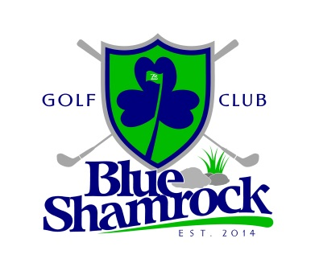
Simple BBQ Buffet: $12.95/per person
Grilled Hot Dogs
Grilled ¼ lb Burgers
Lettuce, Tomato, Onions & Assorted Condiments
Assorted Sliced Cheese
Brown Sugar Baked Beans
Classic Red Potato Salad
Cole Slaw
Fresh Baked Cookie Assortment
Deli Platter Buffet: $12.95/per person
Mixed Greens Salad with Carrots, Tomato, Cucumber, and Assorted Dressings
Pasta Salad
Assorted Sliced Breads
Smoked Ham, Roasted Turkey, Roast Beef, Tuna (choose 3)
Cheddar and Provolone Cheese
Lettuce, Tomato, Onion & Assorted Condiments
Fresh Baked Cookies and Brownies
Beverage Options:
All Beverage items must be purchased from Blue Shamrock Golf Club. Alcoholic beverages are not permitted to be brought onto the premises per PLCB law by either the tournament committee or outing participants.
Beverage Cart on the Golf Course for your event:
You may request that our beverage cart circulate the golf course with standard alcoholic and non-alcoholic beverages and snacks available for sale to outing participants. There will be a $50.00 attendant’s fee for Blue Shamrock to provide the beverage cart for your event.
Open Bar or other beverage options for your event:
Please enquire with the Blue Shamrock Staff if you are interested in offering an open bar of any kind for your outing participants at your event, or have any other beverage needs. We can customize a package to meet your needs for your participants.

